MPM2D Culminating Project (2 hours, 10%)
Instructions
In this culminating project, you will apply your understanding of the concepts and skills you have developed throughout the course to solve a series of problems. The main focus of this assignment is on communicating the thinking you use to select and apply strategies.
For each of the following questions:
A) Solve the problem showing all steps.
B) Write a reflection describing the thought process you used to determine the strategy you chose.
Question #1: Create a system of linear equations that has no solutions, one solution, and infinite solutions. Then, verify the number of solutions both algebraically and graphically (by hand).
Question #2: Determine the equation of the parabola shown below in factored form. Convert your answer to both standard form and vertex form.
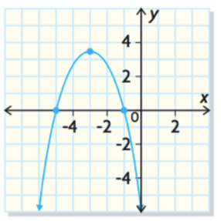

Question #3: Factor the following expressions, where possible, by selecting the appropriate strategy.
- 64a⁶ – 25
- 4x²y – 44xy + 72y
- 6n² – 11ny – 10y²
Question #4: Write each of the following quadratic expressions in vertex form using the most appropriate strategy. In your reflection, be sure to reflect on and explain why your strategy is better than other possible ways of solving this problem.
- y = x² – 6x – 8
- y = -2(x + 3)(x – 7)
Question #5: Determine the value of k for which the following quadratic has one x-intercept.

